1. There is error.

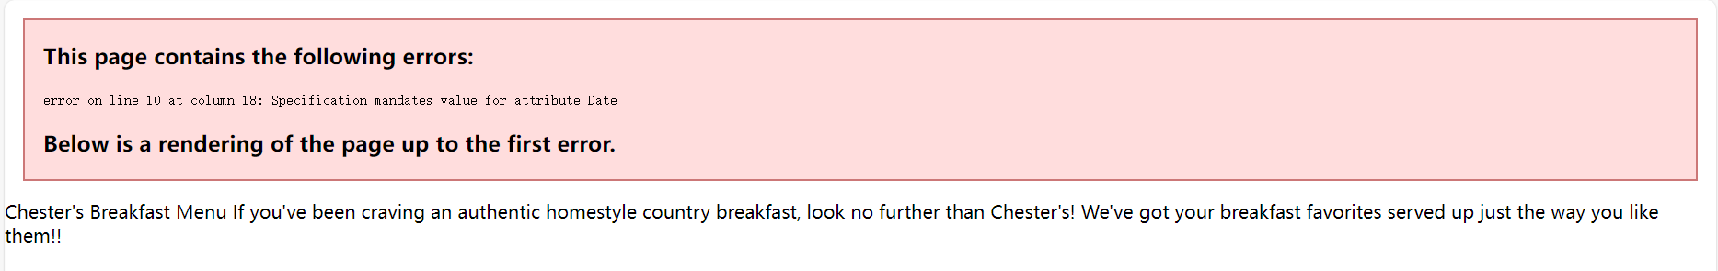

No spaces in between



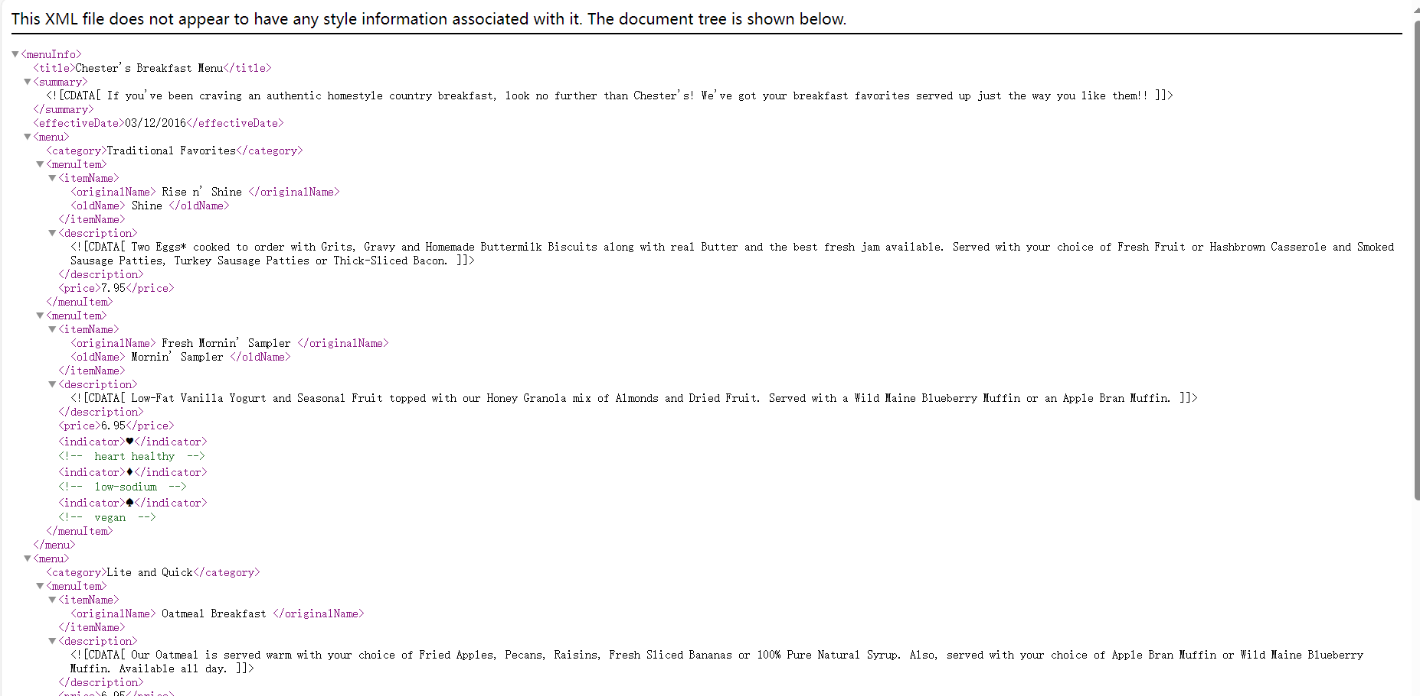

1. <!-- Name: Guo Xinfu ID:n01611988-->

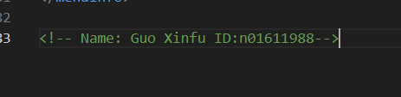

1. Prolog is the first line of this file; document body is from menuinfo to /meneinfo; the the epilog is my name and id.
2. DTD

<!DOCTYPE menuInfo [

<!ELEMENT menuInfo (title, summary, effectiveDate, menu+)>

<!ELEMENT title (#PCDATA)>

<!ELEMENT summary (#PCDATA)>

<!ELEMENT effectiveDate (#PCDATA)>

<!ELEMENT menu (category, menuItem+)>

<!ELEMENT category (#PCDATA)>

<!ELEMENT menuItem (itemName, description, price, indicator*)>

<!ELEMENT itemName (originalName, oldName*)>

<!ELEMENT originalName (#PCDATA)>

<!ELEMENT oldName (#PCDATA)>

<!ELEMENT description (#PCDATA)>

<!ELEMENT price (#PCDATA)>

<!ELEMENT indicator (#PCDATA)>

]>

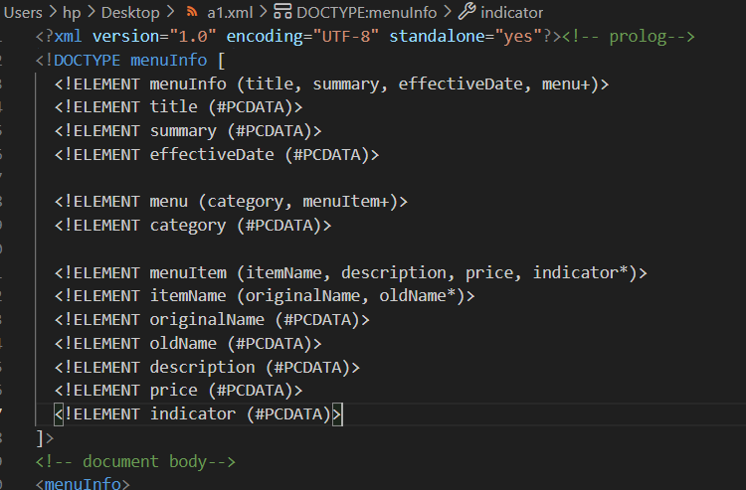



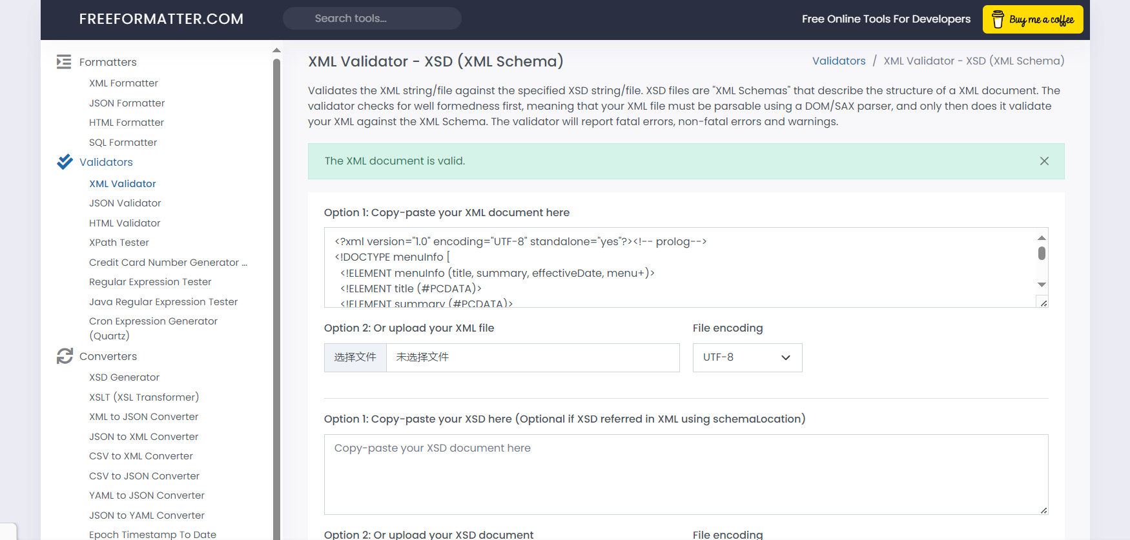



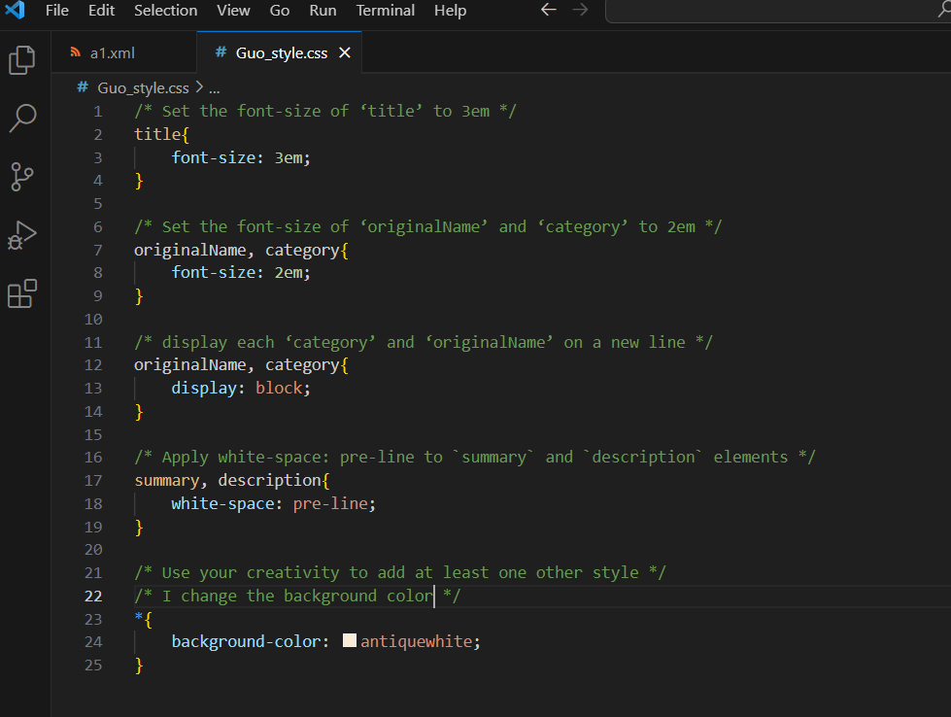

1. <?xml version="1.0" encoding="UTF-8" standalone="yes"?>

Yes, this line is processing instructions.

The version of XML is 1.0

The character encoding is “UTF-8”

Standalone is about if this XML file have external resources.

And there is one thing that css file is not external resources, because standalone="no" suggests that the document may rely on external entities or a Document Type Definition (DTD).

1. The special conformity of a passage may be recognized in the code as a function of the

programming language, which can cause the file to report an error. But using CDATA（Character Data） makes everything in this block follow textual information.

